PHASE 1 REPORT – CRISP-DM
Hotel booking demand
Salma Ahmad Abdelhamid – 230101136
Malak Mohamed Salah Abdelaziz - 230102892

1. Introduction (CRISP-DM Framework)
This project follows the CRISP-DM (Cross-Industry Standard Process for Data Mining) methodology, which provides a structured approach to solving data mining problems. The process consists of six phases:
- Business Understanding
- Data Understanding
- Data Preparation
- Modeling
- Evaluation
- Deployment
This report focuses on the first three phases: Business Understanding, Data Understanding, and initial Data Preparation planning.

2. Business Understanding
2.1. Problem Statement
What is the main problem?
The hotel industry faces significant challenges due to booking cancellations, which lead to:
- Uncertain revenue forecasts
- Inefficient resource allocation
- Loss of potential revenue opportunities
This project aims to develop a predictive model to determine whether a certain booking will be canceled based on customer and booking characteristics.
2.2 Business Objectives
- Financial Impact: Cancellations directly affect hotel revenue and profitability
- Operational Efficiency: Better prediction enables optimal staffing and resource planning
- Revenue Management: Helps in developing effective overbooking strategies without compromising customer experience
- Marketing Optimization: Allows targeted retention efforts for high-risk cancellation segments
2.3 Who is affected by this problem or who will benefit from solving it?
- Hotel Management: For better decision-making and revenue optimization
- Revenue Managers: To set accurate overbooking policies
- Marketing Teams: To design targeted campaigns for at-risk customers
- Customers: Through improved service and potentially better pricing strategies
3. Dataset Description
- Source: Kaggle
- Link: Hotel booking demand
- Number of rows: 119,390
- Number of columns: 32
- Mixed data types: Numerical, categorical, and datetime features

Column Description Table
Column Name | Data Type | Description
hotel | Categorical | Type of hotel (Resort Hotel or City Hotel)
is_canceled | Binary | Target variable: Whether booking was canceled (1) or not (0)
lead_time | Numerical | Number of days between booking and arrival
arrival_date_year | Numerical | Year of arrival date
arrival_date_month | Categorical | Month of arrival date
arrival_date_week_number | Numerical | Week number of arrival date
arrival_date_day_of_month | Numerical | Day of month of arrival date
stays_in_weekend_nights | Numerical | Number of weekend nights stayed
stays_in_week_nights | Numerical | Number of weeknights stayed
adults | Numerical | Number of adults
children | Numerical | Number of children
babies | Numerical | Number of babies
meal | Categorical | Type of meal booked
country | Categorical | Country of origin
market_segment | Categorical | Market segment designation
distribution_channel | Categorical | Booking distribution channel
is_repeated_guest | Binary | Whether guest is repeated (1) or not (0)
previous_cancellations | Numerical | Number of previous cancellations
previous_bookings_not_canceled | Numerical | Number of previous bookings not canceled
reserved_room_type | Categorical | Code of room type reserved
assigned_room_type | Categorical | Code of room type assigned
booking_changes | Numerical | Number of changes made to booking
deposit_type | Categorical | Type of deposit made
agent | Categorical | ID of travel agent
company | Categorical | ID of company
days_in_waiting_list | Numerical | Number of days on waiting list
customer_type | Categorical | Type of customer
adr | Numerical | Average Daily Rate
required_car_parking_spaces | Numerical | Number of parking spaces required
total_of_special_requests | Numerical | Number of special requests
reservation_status | Categorical | Reservation status (Check-Out, Canceled, No-Show)
reservation_status_date | Date | Date of last reservation status
4. Project Objective
This project follows the CRISP-DM (Cross-Industry Standard Process for Data Mining) methodology, which provides a structured approach to solving data mining problems. The process consists of six phases: Business Understanding, Data Understanding, Data Preparation, Modeling, Evaluation, and Deployment.
This project aims to develop a machine learning model that can accurately predict hotel booking cancellations. By analyzing historical booking data and customer characteristics, we will build a classification model that identifies high-risk cancellation bookings. The final delivery will be a predictive system that can help hotel management optimize their overbooking strategies, improve revenue forecasting, and implement targeted customer retention measures.
5. Initial Data Exploration (Basic EDA)
• Screenshots of: df.head(), df.info(), and df.describe()
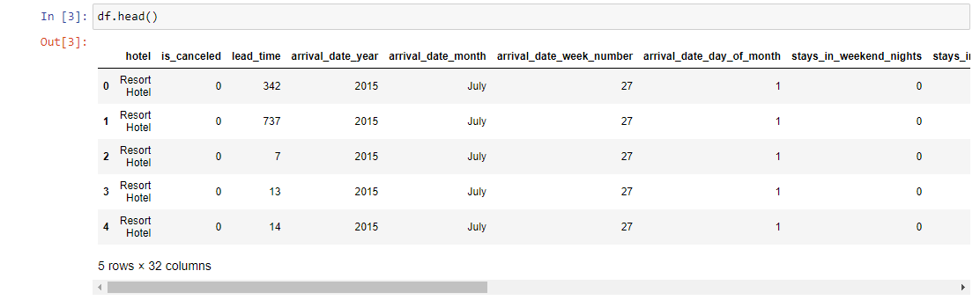
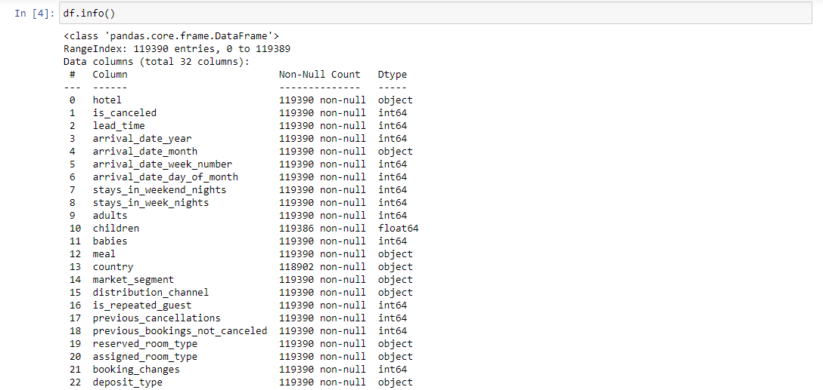
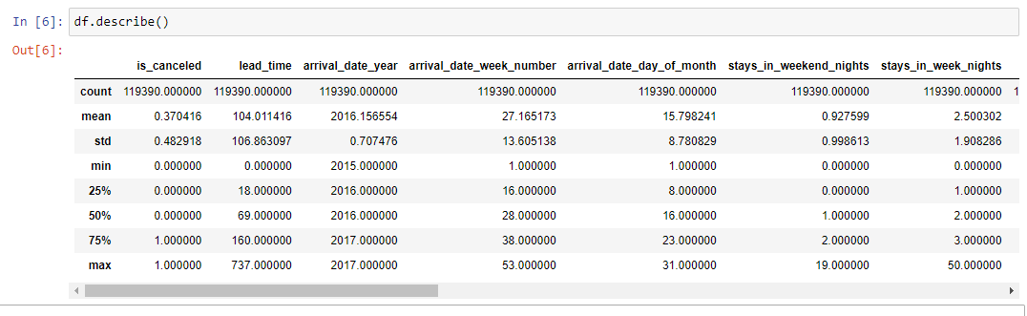

• Brief Discussion of Initial Data Exploration

Presence of Missing Values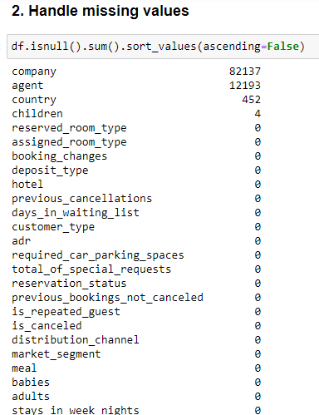
The dataset contains missing values in a few key columns. Most missing entries appear in the agent, company, and country features.
These missing values are expected because many bookings are made without an assigned agent or company, and some records may lack country information due to system limitations.
Since these missing values represent real-world conditions rather than errors, they will be handled by treating them as “Unknown” categories instead of removing the rows.

Presence of Duplicates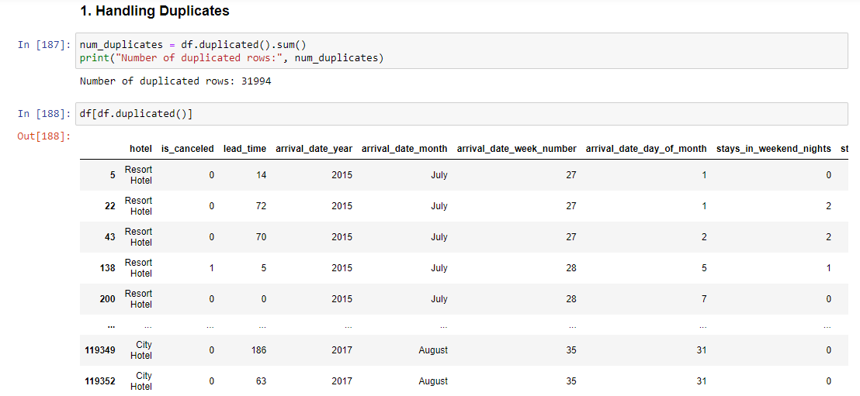
The dataset includes a noticeable number of fully duplicated rows. These duplicates likely result from repeated data extraction or system-level duplication during data collection.
Duplicates can distort statistical patterns and introduce bias in modeling; therefore, they will be removed to ensure a clean and accurate dataset for further analysis.

Presence of Outliers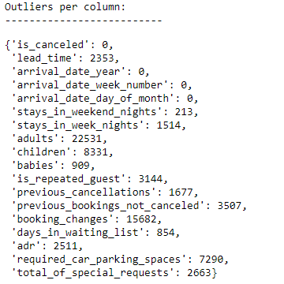
Several numerical columns contain extreme or unusual values.
Examples include:
- adr (Average Daily Rate) includes abnormally high values that may not reflect typical pricing.
- children and babies include unusually large counts that may indicate data entry issues.
- lead_time contains very high values that may represent rare but valid long-term bookings.
These outliers need closer inspection to determine whether they are genuine rare events or errors that should be capped or removed.

Target Variable Imbalance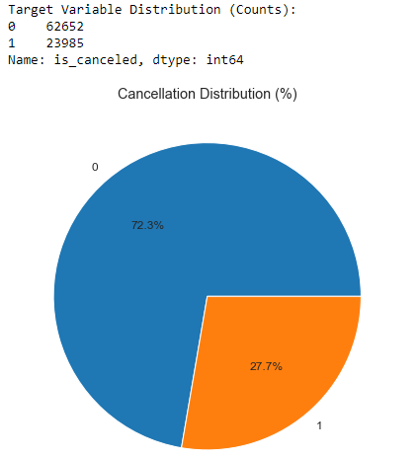
The target variable is_canceled is mildly imbalanced. Typically, cancellations represent around 28% of the data, while non-cancellations make up around 72%.
Although the imbalance is not extreme, it may influence model performance and will be addressed using appropriate validation strategies (such as stratified splits) in later phases.

• Visualization:
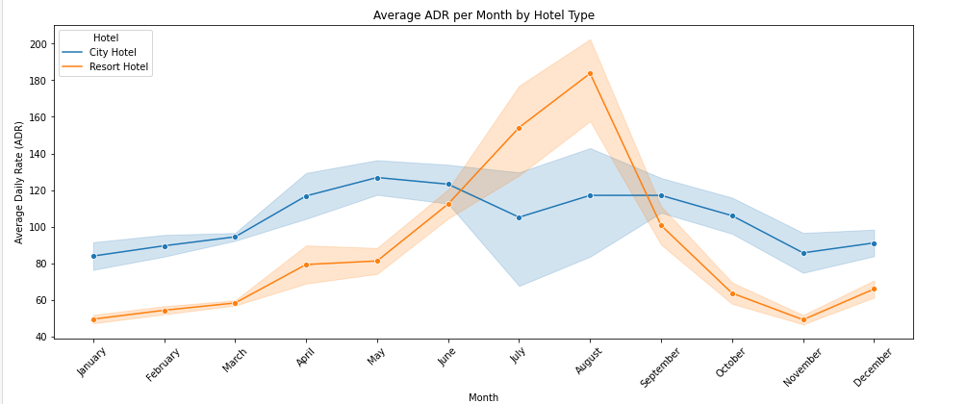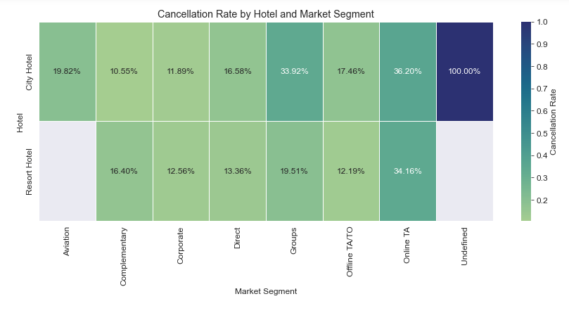
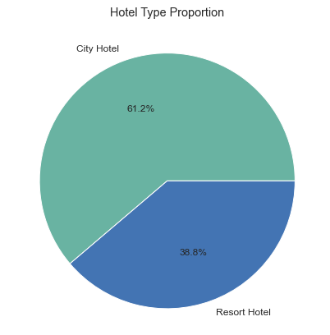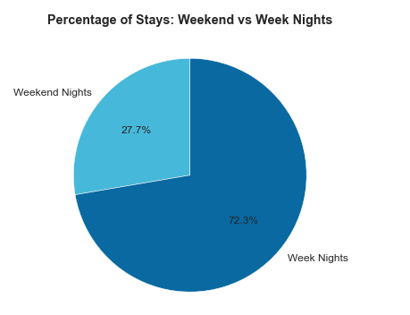
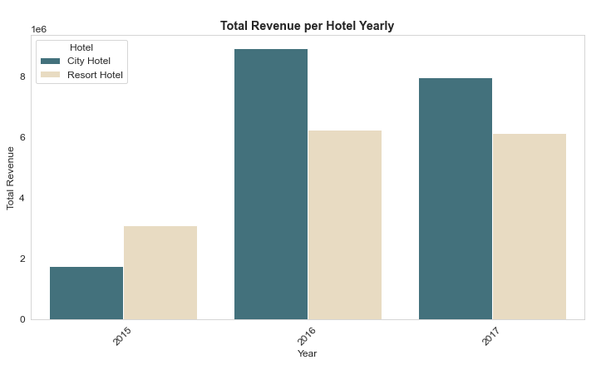

6. Expected Challenges
During the initial exploration of the Hotel Booking Demand dataset, several challenges are expected to arise:
1. Missing Values
Certain columns such as agent, company, and country contain missing values. These may represent genuine unknowns but still require careful handling to avoid bias.
2. Outliers in Numerical Features
Columns like adr, lead_time, children, and babies contain extreme values. Some may be legitimate rare cases, while others may be data entry errors. Outliers may distort statistical summaries and model performance.
3. Duplicated Records
A notable number of fully duplicated rows exist. These redundant entries can inflate sample size and distort analysis unless removed.
4. Noisy or Inconsistent Data
Some categorical variables have inconsistent or overly granular category levels (e.g., countries with very low frequency), which may complicate modeling.
5. High Cardinality in Categorical Columns
Columns such as country, agent, and company have many unique values. High cardinality can increase model complexity and slow down preprocessing.
6. Imbalanced Target Variable
The target variable is_canceled is moderately imbalanced, which may influence model training and accuracy if not handled properly.
7. Multi-part Date Features
The dataset provides separate columns for year, month, day, and week number. Without converting them into a proper datetime format, analyzing seasonality or trends will be difficult.

7. How These Challenges Will Be Addressed
To ensure data quality and prepare the dataset for modeling in Phase 2, the following steps will be taken:
1. Handling Missing Values
- Replace missing agent and company values with a placeholder such as "Unknown" instead of numeric imputation, since these represent categories.
- Consider grouping rare country values under “Other”.
2. Removing Duplicates
- Eliminate all fully duplicated rows to prevent data distortion and reduce redundancy.
3. Addressing Outliers
- Use the IQR method and visualizations (boxplots, histograms) to identify extreme values.
- Decide whether to remove outliers, cap them, or keep them based on domain understanding.
4. Standardizing Categorical Features
- Convert object-type columns to categorical dtype.
- Group low-frequency categories where appropriate to reduce cardinality.
5. Target Imbalance Management
- Use stratified sampling for train–test splits.
- Consider class weighting or resampling techniques later if needed for modeling.
6. Creating a Unified Date Feature
- Combine the year, month, and day columns into a single arrival_date column.
- This will support trend analysis, time-based features, and better temporal understanding.
7. Scaling and Encoding
- Apply label encoding, one-hot encoding, or target encoding for categorical features depending on model requirements.
- Scale numerical variables as needed (especially for distance-based models).

8. Full CRISP-DM Project Plan
This project strictly follows the CRISP-DM methodology. The table below maps all six phases to the specific activities we plan to perform, along with the responsible team members and an estimated timeline.

Phase | Main Activities | Key Deliverables | Timeline | Responsible
1. Business Understanding | Define problem, business objectives, success criteria, and stakeholder needs | Problem statement, objectives, impact analysis | Week 1 | Both
2. Data Understanding | Collect dataset, perform initial EDA (descriptive stats, visualizations), identify quality issues (missing values, duplicates, outliers, imbalance) | Dataset description, EDA report, quality assessment | Week 1–2 | Both
3. Data Preparation | Remove duplicates, handle missing values, treat outliers, create unified arrival_date, feature engineering (seasonality, total nights, etc.), encoding categorical variables, scaling numerical features, train-test split (stratified) | Cleaned dataset, preprocessing pipeline | Week 2–3 | Salma
4. Modeling | Build baseline models, train multiple classification algorithms, hyperparameter tuning, handle class imbalance (class weights / SMOTE if needed) | Trained models, feature importance analysis | Week 3–4 | Malak
5. Evaluation | Evaluate using Accuracy, Precision, Recall, F1-score, ROC-AUC, Confusion Matrix. Compare models, perform cross-validation, analyze errors | Model performance report, best model selection | Week 4 | Both
6. Deployment | Create a simple interactive dashboard (Streamlit or Power BI), document the model, provide usage guidelines and limitations | Interactive dashboard + final project documentation | Week 5 | Both

9. Technique Selection Rationale (Modeling Techniques)
We will apply classification algorithms to predict the binary target variable is_canceled. The following techniques were selected based on the nature of the dataset (mixed numerical + categorical features, moderate imbalance, presence of outliers, and high cardinality in some columns):
- Logistic Regression — Baseline model. Chosen for its simplicity, interpretability, and fast training time. It will help us understand linear relationships.
- Random Forest — Primary ensemble model. Excellent for handling mixed data types, robust to outliers, and provides built-in feature importance. Commonly achieves strong performance on hotel cancellation datasets.
- XGBoost — Advanced gradient boosting model. Selected for its high predictive power, ability to handle imbalance (via scale_pos_weight), built-in regularization to prevent overfitting, and speed with large datasets. Expected to deliver the best overall performance.
- (Optional) LightGBM or CatBoost — If time permits, for comparison, as they are efficient with high-cardinality categorical features.
Why these techniques suit the problem:
- Tree-based models (Random Forest & XGBoost) naturally handle non-linear relationships, missing values (after preprocessing), and mixed feature types without heavy scaling.
- They are robust to the mild class imbalance and outliers present in features like lead_time and adr.
- Interpretability tools (SHAP or feature importance) will be used to explain which factors (e.g., lead_time, deposit_type, market_segment) most influence cancellations — valuable for hotel management.
We will use 5-fold stratified cross-validation during training and tune hyperparameters using GridSearchCV or RandomizedSearchCV.

10. GitHub Repository
Repository Link: https://github.com/malakmehanaa/dm-final-hospitality-team15
We have initialized a public GitHub repository for this project to ensure version control, collaboration, and reproducibility.
Repository Details:
- URL: https://github.com/malakmehanaa/dm-final-hospitality-team15
- Structure:
  - /data/ — (raw and processed datasets — .gitignore excludes large files)
  - /notebooks/ — Jupyter notebooks for EDA, preprocessing, and modeling
  - /src/ — Python scripts for reusable functions (preprocessing, modeling)
  - /reports/ — Phase reports and final documentation
  - /dashboard/ — Streamlit app files (for Phase 2)
  - requirements.txt — List of required Python packages
  - README.md — Project overview, how to run the code, team members, and results summary
  - .gitignore — Standard Python + data science ignores
- Commits: Each team member has made at least one meaningful commit (initial structure + Phase 1 report upload).
- Collaboration: We are using branches (main + feature branches) and pull requests for changes.
The repository is ready and publicly accessible for review.

